EMERGENCY SOLUTIONS GRANTS PROGRAM

2019
POLICIES & PROCEDURES
IMPLEMENTATION MANUAL

735 Riverside Drive
Jackson, Mississippi 39202

601.718.4642 phone
601.718.4643 fax

www.mshomecorp.com
EMERGENCY SOLUTIONS GRANTS POLICIES & PROCEDURES IMPLEMENTATION MANUAL

TABLE OF CONTENTS

I. INTRODUCTION Page
A. Overview of Implementation Process 3
B. National Strategic Goals/Priorities 6
C. Responsibilities of the Non-Profit Organizations 9
D. Avoiding Problems 10

II. FINANCIAL MANAGEMENT
A. Contract 13
B. Requests for Cash and Consolidated Support Sheet 14
Request for Cash Instructions 14
Consolidated Support Sheet Instructions 16
C. State/Sub-Recipient Responsibilities……………………………………………….. 17
D. Sample Authorization Signatory Letter………………………………………………18
Request for Cash Appendix…………………………………………………………..19
E. Budget Modifications and Contract Extensions 26
F. Monitoring and Closeout Procedures 26
G. Recordkeeping 27

III. GENERAL AREAS OF COMPLIANCE
A. Environmental 30
B. Procurement Guidelines 30
C. Fair Housing/Equal Opportunity 31
D. Section 3 37
Section 3 Summary Report 38
E. Audits 41
Funding Certification Form 42

IV. HOMELESSNESS PREVENTION/RAPID RE-HOUSING
A. Program Components …………………………………………………………………43
B. Program Requirements ………………………………………………………………..51
C. Mandatory Documentation……………………………………………………………..52

Appendix
Required Forms
Definitions of Homelessness
Documentation of Homelessness
ESG Application
Employment Verification
ESG Income Eligibility Worksheet
Affidavit of Arrears
Rental Assistance Agreement
Rent Reasonableness Checklist
Habitability Standards Checklist
Lead-Based Paint Checklist
ESG Termination of Assistance
ESG Assistance Checklist
HUD Regulations
- INTRODUCTION

On May 20, 2009 the Homeless Emergency Assistance and Rapid Transition
to Housing Act of 2009 (HEARTH) was enacted into law. The HEARTH Act consolidates three of the separate homeless assistance programs administered
by HUD under the McKinney-Vento Homeless Assistance Act into a single grant program and revises the Emergency Shelter Grants program and renames it the Emergency Solutions Grants (ESG) program.

The change in the programs’ name from Emergency Shelter Grants to Emergency Solutions Grants reflects the change in the programs’ focus from addressing the needs of homeless people in emergency or transitional shelters to assisting people to quickly regain stability in permanent housing after experiencing a housing crisis and/or homelessness. There are two (2) major additions to the program: the homelessness prevention component of the program; and the new rapid re-housing program component. The homelessness prevention component includes various housing relocation and stabilization services with short-term rental assistance to help people avoid becoming homeless. Medium-term rental assistance may be provided for up to 24 months. The rapid re-housing assistance component includes similar services to help people who are homeless move quickly into permanent housing and achieve stability in that housing.

A third component of the ESG program includes the provision of essential services. Allowable essential services include the utilization of case management activities from program entrance to program exit. Case managers can be reimbursed for travel as it relates to shelter, rapid rehousing and homelessness prevention activities. The reimbursement is based on the federal rate for mileage. Essential services can also be used to purchase gas, bus passes and taxi vouchers for program participants. These essential services and staff cost are maximized at fifty percent (50%) of the total amount of the grant allocation. The 50% may be allocated in any combination of activities but not to exceed the total of 50% of the amount of the grant.

- OVERVIEW OF IMPLEMENTATION PROCESS

Purpose – The Emergency Solutions Grants Program (ESG) Policies and Procedures Implementation Manual is a collection of guidance and instructional materials, relevant information, forms, requirements, and other data necessary for the implementation of an ESG project.

Objectives – The objectives of the program are to assist the recipient in accomplishing the following:

a. Providing financial assistance to homeless persons and/or those at risk of homelessness;
b. Meeting the needs of special groups within the homeless population;
c. Providing essential services; and
d. Shelter Operation and Maintenance.

The Emergency Solutions Grants program continues to reflect changes
in the programs’ focus from addressing the needs of homeless people in emergency or transitional shelters to assisting people to quickly regain stability
in permanent housing after experiencing a housing crisis and/or homelessness. This program broadens existing emergency shelter and homelessness prevention activities and adds short-term rental assistance to help people avoid becoming homeless. Medium-term rental assistance may be provided for up to 24 months. The rapid re-housing assistance component includes similar services to help people who are homeless move quickly into housing and achieve stability in that housing.

Applicability – This manual applies to the implementation of the Emergency Solutions Grants (ESG) Program as authorized by subtitle B of title IV of the McKinney-Vento Homeless Assistance Act (42 U.S.C. 11371-11378). The program authorizes Mississippi Home Corporation to make grants to non-profit organizations for reimbursement of eligible expenses related to operating shelters, for essential services including case management, homelessness prevention and rapid-rehousing assistance.

Audience – This manual is for all sub-recipients involved in the implementation of the program listed above. The manual addresses program areas of compliance, which include Environmental, Procurement, Financial Management, Fair Housing/Equal Opportunity, Section 3 Regulations, and Emergency Solutions Grant Regulations. All sub-recipients should be familiar with the information contained in the manual.

Approach to Implementation – Sub-recipient staff should view the implementation of an ESG project as a continuous learning process. All staff should be knowledgeable of program requirements. Communication with ESG staff and compliance officers, review of policy statements and instructions, attending workshops conducted by MHC and a thorough review of this manual should assist in developing a strong knowledge base of the program.

The following provides a simplified version of beginning the implementation process.

• The ESG Staff provides contracts to sub-recipients and conducts the implementation workshop to provide guidance and materials necessary to implement an ESG project.

- The environmental process should begin immediately to meet the necessary federal requirements and timelines.

- The procurement process should begin for all services required for the project. Instructions for this process are outlined in the procurement section of this manual.

• Submit to MHC the documentation necessary to allow Contract Special Conditions clearance.

- Submit to MHC a Signatory Authority Letter for future Request for Cash and program reporting. There should be no more than two (2) authorized signatories.

• A financial management system must be established about activity and line item budgets contained in the contract. The amount of ESG funds approved in the contract budget will be closely monitored to avoid exceeding the allocated limits.

- A recordkeeping system must be established for the project.

PROGRAM STAFF

The staff involved in ESG program management may be contacted for assistance at the following:

Faye McCall - Assistant Vice President of Grant Management
faye.mccall@mshc.com
(601) 718-4668

Erica Fell - Federal Grant Processing Specialist
rica.fell@mshc.com5
(601) 718-4681

B. NATIONAL STRATEGIC GOALS/PRIORITIES/ OBJECTIVES

Home, together is focused on federal strategies that will support states
and communities to make homelessness a rare, brief, and one-time
experience—and that will sustain that success once achieved. That focus is
reflected in its structure.

- Ensure Homelessness is a Rare Experience

Objective 1.1: Collaboratively Build Lasting Systems that End
Homelessness
Objective 1.2: Increase Capacity and Strengthen Practices to
Prevent Housing Crises and Homelessness

2. Ensure Homelessness is a Brief Experience

Objective 2.1: Identify and Engage All People Experiencing
Homelessness as Quickly as Possible
Objective 2.2: Provide Immediate Access to Low-Barrier Emergency
Shelter or other Temporary Accommodations to All Who Need it
Objective 2.3: Implement Coordinated Entry to Standardize
Assessment and Prioritization Processes and Streamline Connections
to Housing and Services
Objective 2.4: Assist People to Move Swiftly into Permanent Housing
with Appropriate and Person-Centered Services

3. Ensure Homelessness is a One-Time Experience

Objective 3.1: Prevent Returns to Homelessness through Connections
to Adequate Services and Opportunities

4. Sustain an End to Homelessness

Objective 4.1: Sustain Practices and Systems at a Scale Necessary to
Respond to Future Needs

MHC collaborates with CoCs and develops strategic goals guiding the use of ESG funds.

The goals and priorities are:

- Achieve the federal goals stated in Opening Doors: The Federal Strategic Plan to Prevent and End Homelessness and accomplish ambitious goals related to the U.S. Supreme Court decision in Olmstead vs L.C.:

- End and sustain an end to homelessness among veterans by the end of 2018 (funding sources have been defined by VA and SSVF but needs in this population may be addressed using HOME, CoC, and ESG, though could be eligible)

- End and sustain an end to chronic homelessness by the end of 2018 (the partnerships between ESG, HOME, National Housing Trust Fund, CoC and CHOICE could help achieve this goal while also accomplishing Olmstead goals as the populations often overlap homeless persons living with mental illness)

- End and sustain an end to homelessness among families and youth (CoC resources, HOME TBRA, HOME units, National Housing Trust Fund, ESG shelter operations for domestic violence shelters, shelters for women and children, runaway and homeless youth programs, and children’s shelters willing to address trafficking, ESG rapid re-housing and prevention coupled with appropriate services)

- Create a system to ensure that all homelessness is rare, brief, and non-reoccurring (ESG outreach services, navigation services under rapid rehousing, HMIS activities, coordinated entry)

- Create standards within the CoCs to ensure that ESG and CoC programs align with the goals, utilize evidence-based practices, and promote coordination. Outcomes expectations will be defined and measured by HMIS and site visits. The CoCs will get together to create statewide CoC expectations and standards.

- In awarding ESG funding to applicants, MS Home Corp will consider measurable outcomes proposed, service delivery standards and models used, and clearly stated actions by a grantee to meaningfully collaborate with the CoC, and other service organizations in local communities whether funded by ESG or other sources. Grantees will be expected to participate in local coordinated entry, HMIS, PIT, and CoC committee work.

- The CoCs will lead the outreach activities to promote coordinated entry, maintain a by-name list, and make appropriate community referrals. Navigators will assist people who are literally homeless and identified through outreach to access services and housing.

E. The CoCs’ HMIS systems will continue to coordinate efforts and provide data to the community, HUD, and MS Home Corp. The HMIS data over time coupled with the PIT counts will inform the goals and strategies to achieve those goals at a local level. Funding will align with the data-driven goals.

F. MHC, CoCs and ESG funded agencies will coordinate with the Department of Mental Health and Community Mental Health Centers regarding Assertive Community Treatment Teams (ACT Teams) and other community-based services with newly created housing options.

- RESPONSIBILITIES OF THE NON-PROFITS

Non-profits who receive ESG assistance must understand it is their primary responsibility to enforce ALL obligations and regulations in complying with the intent of Congress as declared by the HEARTH Act Final Rule.

Non-profits must ensure that activities undertaken meet the primary objectives
of the Act, its regulations, and the State’s ESG program objectives.

If the State determines that a sub-recipient of ESG funds has failed to comply with any provision of this subpart, the State shall notify the non-profits’ chief executive officer of the noncompliance and shall request the officer to ensure conformity in a timely manner.

Remedial actions and sanctions for failure to meet the ESG program requirement will be designed to prevent a continuation of the deficiency; mitigate, to the extent possible, its adverse effects or consequences; and prevent its recurrence.

The State may instruct the sub-recipient to submit and comply with proposals for actions to correct, mitigate, and prevent noncompliance with ESG requirements including:

- Prepare and follow a schedule of actions for carrying out activities affected by the noncompliance, including schedules, timetables, and milestones necessary to implement the affected activities;

- Establish and follow a management plan that assigns responsibilities for carrying out the remedial actions;

- Cancel or revise activities likely to be affected by the noncompliance, before expending ESG funds for the activities;

- Reprogram ESG funds that have not yet been expended from affected activities to other eligible activities;

- Suspend disbursement of ESG funds for some or all activities;

- Reduce or terminate the remaining grant of sub-recipient and reallocate those funds to other sub-recipients; and

- The State may suspend payments to the extent HUD deems it necessary to preclude the further expenditure of funds for affected activities.

- The State may remove the sub-recipient from participation in reallocations of funds.

- The State may deny matching credit for all or part of the cost of the affected activities and require the sub-recipient to make further matching contributions to make up for the contribution determined ineligible.

- The State may require the sub-recipient to reimburse its line of credit in an amount equal to the funds used for the affected areas.

- The State may reduce or terminate the remaining grant of a sub-recipient and reallocate those funds to other recipients;

- The State may condition a future grant.

- The State may take other remedies that are legally available.

D. AVOIDING PROBLEMS

It is the responsibility of the State to ensure the activities of an ESG project
are administered in accordance with the HEARTH Act. The sub-recipient must ensure that project activities are carried out to avoid problems which violate
the intent of the Act. Although the duties may be delegated, the ultimate responsibility for compliance rests with the non-profit’s executive officers, as a State sub-recipient of ESG funding.

Listed below are some common problems that sub-recipients of ESG projects should be aware of and try to avoid:

Environmental

Contracts were executed prior to MHC environmental clearance apart from contracts for administrative services.

Failure to provide MHC with necessary documentation.

Financial Management

Eligible Matching funds were not expended at a proportionate ratio with ESG funds.

In-kind services were not properly documented.

Representatives of the sub-recipient agency were not adequately bonded; if applicable.

Financial records were not maintained on a current basis or not kept in accordance with standards contained in the State or federal regulations.

All receipts are not recorded in Cash Receipts Ledger.

Bank reconciliation and subsidiary ledgers are not maintained, such as payments and balances.

Unsupported or insufficient support for payments.

Expenditures made prior to the date of the contract or special conditions clearance.

Inadequate procedures for verification of allowable costs.

Program modifications were implemented without prior MHC approval.

Inadequate separation of duties (i.e. person approving expenditures is also disbursing and recording; executive directors paid as case managers).

Fair Housing/Equal Opportunity (FHEO)

FHEO posters (Spanish and English) were not displayed at the shelter premises or at the non-profit’s operation of business.

Procurement

Solicitations for MBE/WBE participation were not obtained.

The sub-recipient fails to have written Procurement Procedures or fails to follow the procurement process.

Administration

Currently, Administration fees are not eligible expenses. Therefore, attending conferences, conventions, membership fees are not allowed.

- FINANCIAL MANAGEMENT

A. CONTRACT

Upon being awarded an Emergency Solutions Grant project, a binding contract is executed between the State of Mississippi and the non-profit organization for the specific amount awarded to the applicant and for the activity selected by the applicant. The contract between the organization and the State is a very important document throughout the life of the project. It identifies the description of the activities funded, budgeted costs, general terms and conditions, and any special conditions which must be met before the State will release funds.

Within the contract document, there are five (5) important segments which grant sub-recipients should be aware. These are listed and further clarified below:

- Signature Sheet – This cover sheet lists the sub-recipient, effective
dates of the contract, grant number, amount of funds awarded, and the attachments detailed below. This sheet is signed by senior management of Mississippi Home Corporation and requires the signature of the local chief executive officer.

- Special Conditions – The environmental regulation is the only special condition that requires written clearance.

- General Terms and Conditions – These terms and conditions cite program authority, rules and regulations pertinent to all ESG Grants.

- Assurances – Compliance with the assurances is committed to by
the signature of the chief executive officer of the non-profit organization
in the original project application. The non-profit contract signatory should carefully review all assurances prior to signing the contract, as that office
is ensuring compliance with all applicable laws, regulations and other requirements of the ESG program.

- Budget – This section of the contract reflects the funds allocated to each project activity area. If the sub-recipient is not sure of an eligible expense, contact the ESG staff for clarification prior to making a commitment of funds. Although not intended to be exhaustive, the following list of allowable program activities is included in the contract.

- REQUESTS FOR CASH / CONSOLIDATED SUPPORT SHEET

Funds are requested by using the Request for Cash and the Consolidated Support Sheet which can be accessed at www.mshomecorp.com. These forms must be accurately completed, or the request will be returned to the sub-recipient. All forms that require a signature, must be signed for the Request for Cash to be reviewed and processed.

For the fund drawdown process to begin a sub-recipient must return its signed grant agreement, complete Environmental Review, clear contract special conditions, W9 and submit a signatory authorization letter to MHC. The signatory authorization letter identifies authorized parties responsible to sign Request for Cash and reporting documents. Once RFC is approved, payment to a recipient will be made through direct mail or automatic deposit.

REQUEST FOR CASH INSTRUCTIONS

The Request for Cash (RFC) form is used by ESG recipients on a cost reimbursement basis to requisition funds. Requests for cash must be submitted ON THE 15TH OF EVERY MONTH FOR THE PERVIOUS MONTHS ACTIVITIES. IF YOU CHOOSE TO SUBMIT TO MORE THAN ONE A MONTH, IT MUST BE SUBMITTED ON THE 30TH OF THE MONTH. Request for reimbursements must be submitted within Ninety (90) days of services provided. Example: If you are submitting an RFC for 08/01/2019-08/15/2019 your request for reimbursement documentation must be dated between May 1, 2019 -July 31,2019. MHC’s fiscal year ends June 30^{th,} therefore, any expenses incurred after that date must be on a separate RFC. The general instructions are as follows:

Section A: General Information

Sub-recipient’s Name / Address / Telephone Number
Choose sub-recipient’s name from the drop-down menu. Included in this will be the mailing address and telephone number.

Section B: Project Information

Grant Number / Contract Number / Request Number / Service Rendered / MCH Staff Initials
Enter the grant number. Enter the contract number as it appears on the contract and the last two (2) digits of the grant year. Enter the request number.

Enter the Services Rendered period. This period must fall within the contract period and the timeframe in which costs occurred. The dates provided in this field are the dates that purchases were made or the dates that an action became known to the sub-recipient (i.e., mail date, invoice date). The Services Rendered period cannot overlap state or sub-recipient fiscal years.

MHC staff will sign off in the MHC Staff Initials space as a part of the review process. MHC is required to make timely payments to each of its sub-recipients within 30 days after the date of receiving the sub-recipient’s complete payment request. If the sub-recipient submits an incomplete or incorrect request for payment, staff will make notification via email and return the request as necessary.

Section C: Request per Activity

Activity Description / Budget Amount / Total Prior Request to Date / This Request / Remaining Balance / Activity Numbers
Enter the name of the activity, the corresponding figures, and activity numbers.

Signatory Section

Final or Interim Request
Check yes if it is the final request or no if there will be future request.

Signature of Authorized Official
The authorized official who must sign the Request for Cash (RFC) is the same official who signed the contract or the approved authorized signatory official.
In case of signatory designation, an authorization letter will be required to be
on file with Mississippi Home Corporation. The authorized official responsible for signing the RFC should not be the same as the preparer of the document. There should be a clear separation of duties.

Typed Name and Title of Authorized Official
Self-Explanatory

Date Signed
Self-Explanatory

Prepared by
Enter preparer’s name. This should be the person most familiar with the data reported, in case of questions. The preparer of the RFC should not be the same as the authorized official responsible for signing the RFC. There should be a clear separation of duties.

Preparer’s Telephone Number
Self-Explanatory

Date Prepared
Self-Explanatory

Completed Requests for Cash forms can be emailed to the following address:

Faye McCall: faye.mccall@mshc.com
Erica Fell: erica.fell@mshc.com

CONSOLIDATED SUPPORT SHEET INSTRUCTIONS

The Consolidated Support Sheet is provided to the sub-recipient for use in documenting the cost proposed for reimbursement in the Request for Cash. It
allows the sub-recipient to report individual cost incurred per each activity area
and to tie that cost by invoice numbers to support documentation. This support sheet allows a sub-recipient to maintain budget balances of activity area costs, federal expenditures, matching contributions, and total expenditures. Completed Consolidated Support Sheets are to be submitted each time a Request for Cash is submitted to MHC. Cost reported must equal the amount requested and disbursed. No Request for Cash will be processed if the Consolidated Support Sheet and the Cumulative Support Sheet is not attached, signed and completed correctly. The Request for Cash will be returned to the sub-recipient and must be re-submitted when completed or corrected. A duplicate copy of each Request for Cash must be retained in the recipient’s file. General instructions are as follows:

Program / Sub-recipient / Request Number / Contract Number / Amount Requested
This information should be populated from the information entered on the Request for Cash

Activity Areas
Enter the name of each activity as shown on the Request for Cash form.

Line Item
Enter a specific eligible activity for each cost item in the Line Item column.

Vendor Name / Invoice Number
Enter the individual vendor name, month of payment and corresponding vendor invoice numbers, ID numbers or names of program participants to reference attached cost documentation.

Total Invoice Amount
Enter the total invoice amount for each item.

Amount of This Request
Enter the amount of the invoice requested for reimbursement.

Match Amount
Enter the amount of match funds to be used towards the activity area based on the available documentation. Enter a line item which describes the type of match (cash donation, value of donated materials, lease value, rent value, staff salary, or volunteer time value), vendor name, and invoice number for each match amount. Federal share and match share must maintain a 1 to 1 ratio as the project progresses and must be at least 1 to 1 at project completion. Match funds are not included in the last three columns of the Consolidated Support Sheet.

Amount Budgeted
Enter the amount of federal funds budgeted for each contracted activity area in this column and on the same row as the activity area title.

Amount Requested to Date
This column contains previously approved and presently requested federal cost. An entry is made of the previously approved federal reimbursement activity total on the same row as “Amount Budgeted” for requests other than the initial. Entries are made for each federal cost item in the same amount as was shown for that item under “Amount of This Request”. These cost entries will automatically inhabit the Balance column and be deducted from the activity area balance.

Grand Total (Invoice Amount)
Activity Area Totals will automatically inhabit the “Total” row for respective activity areas. From these activity totals a grand total will automatically inhabit the “Grand Total” row for each column.

Service Rendered Beginning and Ending
This information will be populated from the Request for Cash in Section B.

Cumulative: Program Expenditures (Federal Share)
Enter the total amount of federal funds requested to date for all activities. This should equal the grand total for “Amount Requested to Date”.

Cumulative: Matching Expenditures (Match Share)
Enter the total amount of matching funds reported to date for all activities. This should equal the grand total for the match column.

Total Expenditures
Enter the sum of the cumulative program expenditures and the cumulative matching expenditures reported to date.

Typed Name and Title of Authorized Official
Enter the name of the authorized official who must sign the Request for Cash. This is the same official who signed the contract or an approved authorized signatory official. In case of signatory designation, an authorization letter will be required to be on file with Mississippi Home Corporation.

C. STATE RESPONSIBILITIES

  - The staff shall process Requests for Cash/Consolidated Support Sheets and forward the documents to the MHC Finance Department within 30 days of a correctly submitted Request for Cash.

In the event of questions, errors, or discrepancies regarding submitted document(s), the MHC staff shall contact the designated sub-recipient financial officer to discuss the issue. The staff will not make any corrections or other changes to the Request for Cash and/or Consolidated Support Sheets. It is
the sub-recipient’s responsibility to submit a true and correct document.

- All Requests for Cash/Consolidated Support Sheets submitted by the sub-recipient shall be maintained by both the ESG staff and the Finance Department of the MHC.

SUB-RECIPIENT RESPONSIBILITIES

- The Request for Cash shall always be accompanied by the Consolidated Support Sheet and invoices to support all costs.

- At least one Request for Cash must be submitted monthly. You may submit more than one after approval, but you must submit AT LEAST one month.

- A Request for Cash must not include cost incurred during two of the sub-recipient State’s fiscal years. An individual cost falls into the fiscal year in which it is incurred based on invoice date.

- Costs eligible for reimbursement must be incurred during the contract period.

- Requests for Cash MUST include documentation to support matching expenditures.

6. The sub-recipient is responsible for providing a CAPER Summary Report monthly. This shall include beneficiary and financial reporting. Failure to submit these documents monthly will result in a delay of processing the Request for Cash.

7. Sub-recipients must comply with policies and procedures for submitting the annual CAPER (HMIS/Comparable Database). All ESG sub-recipients must submit the report to MHC by July 15th of each reporting year. Reporting periods run from July 1 through June 30th of the subsequent year.

8. Sub-recipients must comply with policies and procedures for Section 3 Form #6002 for each open grant. All ESG sub-recipients must submit the form to MHC by July 15th of each reporting year. Reporting periods run from July 1 through June 30th of the subsequent year.

D. SAMPLE SIGNATORY LETTER

Your Organization's Letterhead

Faye McCall
Assistant VP of Grant Management
Mississippi Home Corporation
735 Riverside Drive
Jackson, Mississippi 39202

Dear Mrs. McCall:

This letter is to inform your office of the authorized signature for our ESG Project
Number . (Names of Persons authorized to sign) have/has the authority to sign cash request forms, other project reports and documents related to this project. Thank you for your time and attention to this matter.

AUTHORIZED SIGNATURE(S)

___________________________________ __________________________________
Title Title

I certify that the above persons are authorized as stated above and that the signatures are the original signatures of the persons so stated.

____________________________________
Chief Executive Officer

REQUEST FOR CASH APPENDIX

SAMPLE RFC FORM

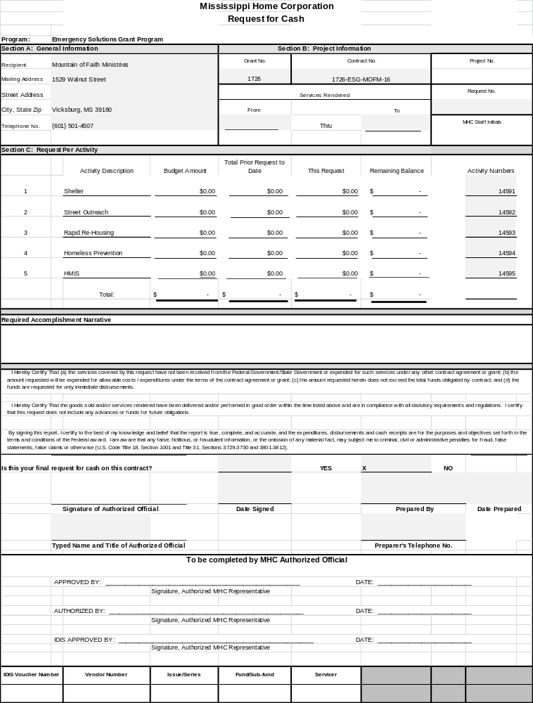
SAMPLE
CONSOLIDATED SUPPORT SHEET

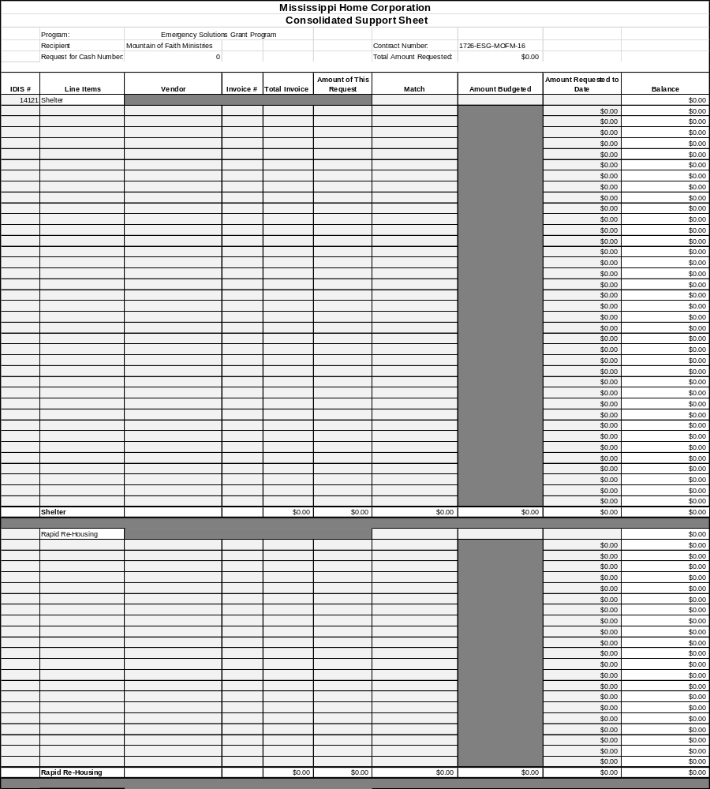

SAMPLE
CONSOLIDATED SUPPORT SHEET

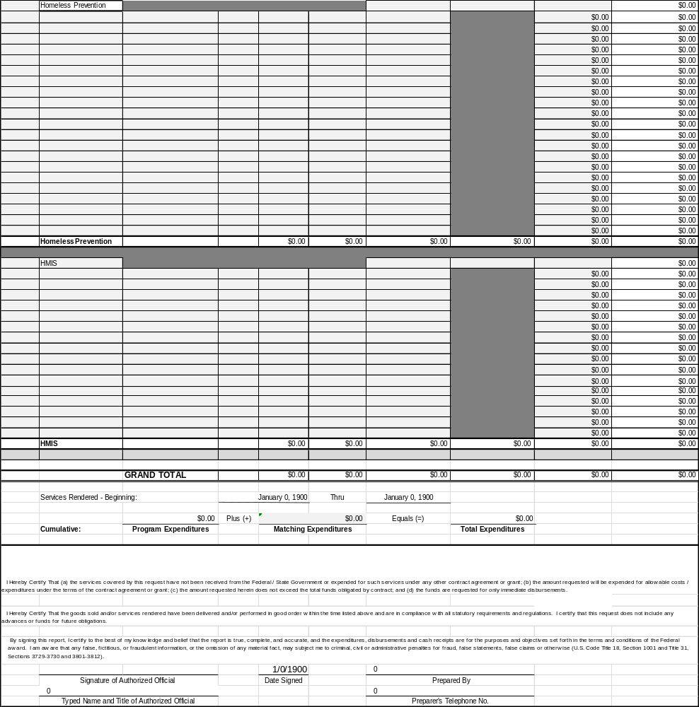

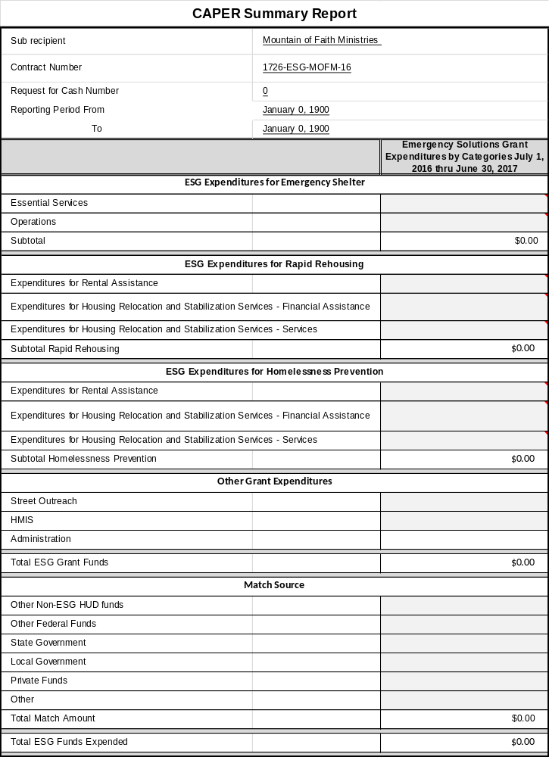

CAPER:

The purpose of CAPER is to generate the Emergency Solutions Grant Consolidated Annual Performance and Evaluation Report. The CAPER needs to be COMPLETED ANNUALLY BY SUB-RECIPIENTS of projects receiving Emergency Solution Grant (ESG) funding and is designed to provide an unduplicated count of persons served in ESG projects, as well as demographic breakdowns of those clients.

The CAPER generated in AWARDS includes only data-related questions.

Please follow the steps below in submitting your CAPER report:

From the AWARDS Home screen, click Administration from the left-hand menu, and then click Fiscal/Program. The Fiscal/Program Reports Menu page is displayed.



Click ESG CAPER. The Emergency Solutions Grant Consolidated Annual Performance and Evaluation Report (ESG CAPER) page is displayed.

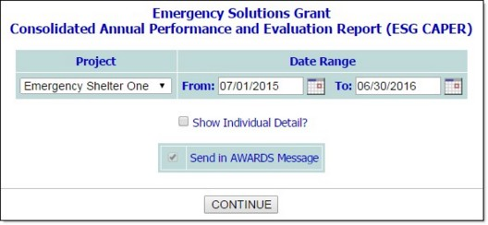

Please make sure you have the correct date range. The reporting range will ALWAYS be July 1st- June 30th.

Click the Project drop-down arrow and select your organization for which the report is to be viewed.

By default, the report's Date Range is July 1st of the previous year, through June 30th of the current year. If necessary, make changes to this default date range using mm/did/yyyy format, or by selecting the correct dates using the available date picker icons.

If necessary, click the Show Individual Detail? box to include a table of individual client-level detail at the bottom of the report page.

When individual detail is included, each client in the report (for any question) is listed on a separate row in the detail table, and each data element needed for the report is shown in a separate column. The table also includes which project (program) each client was active in, and the HMIS Project Type associated with that project. Inclusion of these client details can be particularly useful if it's necessary to troubleshoot report content; however, keep in mind that not every client listed there is counted in every question, as some questions only apply to certain project types.

The Send in AWARDS Messages check box is selected by default and cannot be un-checked. As a result, you need not wait for the report to generate, and can navigate away from the ESG CAPER feature after finishing the configuration process. Once the report is ready for viewing, it is sent to you in the body of a message accessed via your Messages module inbox.

The report will remain in your messages for one month, after which time it will be deleted. (The exact date of deletion will be displayed in red at the top of the report message for your reference.) If you know you will need the report content after that time, be sure to download the Excel file (Excel File.zip) or HTML content (Report Content.html) attached to the report message. If you don't download one of these attachments before the message is deleted, you will need to manually re-generate the report if you need access to it in the future.

Clicks CONTINUE. The report is displayed on the Emergency Solutions Grant Consolidated Annual Performance and Evaluation Report (ESG CAPER) page.

Because the Send in AWARDS Messages option is automatically used by this report, a notice is first displayed on the page to let you know that report generation is in process and that the report will be sent to your Messages module upon completion. You can then navigate away from the page or wait for the report to complete and display.

Download the CSV file versions of the report content for the purposes of submission to HUD; click the CSV Export Files link at the bottom of the report. A zip file containing a CSV for each report question is downloaded to your computer and can then be used by providers to submit data into eCART.

Shelter Utilization

Number of Beds- Rehabbed

Number of Beds- Conversion

Total Number of bed- nights available

Total Number of bed- nights provided

Capacity Utilization

E. BUDGET MODIFICATIONS and CONTRACT EXTENSIONS

MHC requires sub-recipients to receive MHC’s written approval prior to making contract amendments, modifications, or extensions. For MHC to consider a contract change, the sub-recipient must submit an explanation of the need for the change with the executive director’s signature. Some changes to original contracts may require the re-evaluation of an applicant’s eligibility and could result in funding being withdrawn. The sub-recipient will be notified in writing when the State cannot approve a requested revision.

If a requested change is found to be advantageous to the project, MHC will prepare the necessary final documents for review. Once all parties have received copies of the executed contract revision, the requested action may proceed. MHC must approve contract changes prior to local action. Noncompliance may result in ineligible costs and may result in the repayment of grant funds.

Instructions:

Budget Modification

A request for budget modification must include the executive director’s signature and a detailed allocation of funds. If approved, a modification of the contract budget will be prepared by MHC and submitted to the sub-recipient for signature. Budget modifications may include the creation of budgets for new activities/line items and/or the transfer of funds among existing budgeted activities/line items. All budget modifications require written MHC approval.

Contract Extensions

Contract extensions are considered by MHC based on a written request and explanation of need submitted to MHC by the sub-recipient.

F. MONITORING AND CLOSEOUT PROCEDURES

MHC monitors participation to ensure compliance with the grant agreement, together with associated federal, state and local laws, regulation and ordinances. MHC reserves the right to monitor any sub-recipient at any time. Monitoring concentration will include, but is not limited to, financial management, eligible beneficiaries and Homeless Management Information Systems (HMIS)/Comparable Database.

Project monitoring must be conducted prior to closeout. Appointments will be made for monitoring.

G. RECORDKEEPING

The State requires that a recordkeeping system be maintained by all ESG sub-recipients receiving funds administered by MHC. The system must be at least the equivalent of the files as listed below. Failure to maintain an adequate system as determined by MHC staff could result in a finding. Records must be maintained for a period of five (5) years after project close out.

The following file system checklist has been established to help maintain your records:

Project Name: _______________________________________________________

Project Number: _____________________________________________________

APPLICATION FILE

Full application as submitted to State

Additional information submitted

CONTRACT FILE

Award letter

Executed contract

Correspondence concerning contract conditions

Contract modifications and letters of approval

GENERAL CORRESPONDENCE

General correspondence

State general correspondence/memorandums

ESG REPORT

___ Certification of Match

___ Confidentiality Procedures

___ Monthly Statistical Reports

STATE MONITORING FILE

State reports of results of monitoring reviews/ recommendations

Sub-recipient’s response to State monitoring reports

Other correspondence related to State monitoring visits

ENVIRONMENTAL REVIEW RECORD FILE

Copy of "Environmental Review Record" as submitted to MHC

Notice of "Removal of Contract Conditions and Release of Funds"

Letter of Clearance from the Department of Archives and History (only for renovations)

Finding of Exemption

FINANCIAL MANAGEMENT FILE

"Authorized Signature Letter"

"Requests for Cash" and Support Sheets

General ledger and disbursements journal (Example included in Exhibits)

Invoices, pay estimates, receipts of payments of program costs

Documentation of "In-Kind" expenditures (if applicable)

Documentation to support cash contributions or any match funds (if applicable)

PROCUREMENT FILE (if applicable)

Proof of Publication of Requests for proposals/bids

Written Selection Procedures

Proof of Solicitations for proposals/bids

Proposals/bids received

Evaluations of proposals/bids received

Written statements of acceptance of proposals/bids

Executed contracts for each service required; NOTE: All contracts must contain the provisions listed in 24 CFR Part 85 or 24 CFR Part 84, whichever applies.

___ Copies of written notification of procurement Requests for Proposals to the Mississippi Contract Procurement Center

EQUAL OPPORTUNITY/FAIR HOUSING FILE

Documentation of total number of female heads of households, minorities, handicapped, elderly and children who are beneficiaries

Documentation of affirmatively promoting fair housing or of making known availability of services

Employment information of the administrative agency

Community population (if applicable)

Contractor/Subcontractor Activity Reports (if applicable)

Documentation of attempts to solicit minority/female businesses

AUDITS

Audit for each year included in grant period

Evidence clearing all audit exceptions

SECTION 3

HUD Form 60002

- GENERAL AREAS OF COMPLIANCE

- ENVIRONMENTAL

Refer to MHC Environmental Policy & Procedures Manual found on MHC’s website at www.mshc.com.

B. PROCUREMENT GUIDELINES
Procurement policy for programs administered by Mississippi Home Corporation is governed by Federal Regulation 24 CFR Part 84 and the policies are set forth in MHC Policy Statements and/or Instructions. The following procurement standards are currently in effect.

These policies and instructions are modified periodically in response to changing state laws or program conditions.

SMALL PURCHASES

1. Nonprofessional services or supplies which do not involve an expenditure of more than $5,000 may be purchased without advertising. This method of procurement lends itself best to simple, informal purchases in which written price quotations (at least two) are obtained from an adequate number of qualified sources. If the purchase of one item is at least $1,000 but not more than $5,000, then certain documentation is necessary. Documentation of procurement would include a description of supplies or services needed, a list of vendors or suppliers called, and price quotes obtained. Selection would be based on lowest and best supplier.

2. If the aggregate cost is more than $5,000, but not more than $50,000, supplies or nonprofessional services may be obtained from the lowest and best bidder without advertising for bids, provided at least two (2) competitive written bids have been obtained. Documentation of procurement would include description of supplies or service needed, list of vendors or suppliers called or notified, and written individual quotes from each contacted vendor or supplier. Selection would be based on lowest and best supplier.

Written procurement policy should be available for review and all contracts should be in writing.

Procurement History Records – Procurement history records must include
the rationale for the method of procurement used, selection of contract type, contractor selection/rejection, and basis for contract price.

Conflict of Interest – Recipient will maintain a written code of standards of conduct governing the performance of their employees engaged in the award and administration of contracts. Conflict of interest provisions listed at 24 CFR Part 84.45 is to be incorporated.

C. FAIR HOUSING/EQUAL OPPORTUNITY

The guarantee of civil rights has a constitutional as well as a statutory base. Several laws overlap in their coverage of certain actions and activities.

The authority for complaint investigation and compliance determination is retained within HUD.

Civil Rights Requirements

All recipients of Mississippi ESG funds are required to comply with the Civil Rights requirements of Title I of the Housing and Community Development Act and the Fair Housing Laws including the following:

 Title VI, Civil Rights Act of 1964

 Housing and Community Development Act of 1974, as amended

 Title VIII, Civil Rights Act of 1968, as amended--or, the Fair Housing Act

 Housing and Urban Development Act of 1968

 Section 504, Rehabilitation Act of 1973, as amended

 Age Discrimination Act or 1975, as amended

 Executive Order 11063, as amended

 Executive Order 11246 as amended

. Executive Order 13279 as amended

 Section (3) Three, Housing and Urban Development Act of 1969, as amended

Regulations

The following are the applicable regulations:

 24 CFR Part I

 24 CFR Part 8 issued 6/2/88

 24 CFR Part 570

 24 CFR Part 200

 24 CFR Parts 105, 107, 108, 109, 110, 115, 135

 41 CFR Chapter 60

 28 CFR Part 42

 45 CFR Part 91

The Fair Housing and Equal Opportunity requirements affect every aspect of the Emergency Solutions Grant Program. Civil rights laws are designed to protect individuals from discrimination based on the following:

 Race
 Color-ethnicity
 Sex
 National Origin
 Age
 Handicap
 Families with children

As Civil Rights apply to the ESG Program, they protect individuals from discrimination in the following categories:

 Housing
 Benefits and services created by ESG projects
 Employment
 Business opportunities
 Relocation resulting from ESG-funded activities

The following are individuals protected:

 Minorities
 Women
 Groups Distinguished by Age
 Handicapped Persons

The States by certifying their compliance with applicable civil rights laws, assure that methods of administration at the state and local level will be adequate to meet the requirements of the civil rights laws.

Sub-recipient records for fair housing requirements compliance must adhere to 24 CFR Parts 1 and 107.

To document compliance with fair housing requirements, sub-recipients’ records must include the following:

- Documentation of any sub-recipient actions to affirmatively further fair housing (including providing funds, if applicable, for each action).

- For direct benefit activities, data must be maintained on the extent of participation and benefit by individuals involved in a program or activity funded totally or partially with ESG funds. Such records must be kept by race, ethnicity, and gender of head of household, children, and handicap status. For area wide activities, documentation must include the following:

- A description of geographic boundaries of the service area,

- A description of the service being provided to the area, and

- The race and ethnicity of the area

- Data on employment in each of the local government's operating units funded totally or partially with ESG funds. Data must be maintained for the categories prescribed in the Equal Employment Opportunity Commission's EEO-4 form.

- Data on persons in households displaced because of ESG activities, including the following:

- The race and ethnicity of the households,

- The handicap status of any displaced persons, and

- The address to which each displaced household is relocated

- Where ESG activities cause a significant level of displacement of businesses, records must include data indicating the impact on businesses owned by minorities and women.

By signing the Certification of Assurance, the applicant is required to follow the bidding and negotiation requirements under Section 135.25 of the Section 3 Regulations (Title 24 CFR Part 135) and shall develop an affirmative action plan as specified in Section 135.70 for the use of businesses located in or owned in substantial part by persons residing in the area. Sub-recipients must document all efforts to meet these required actions and must report the progress made toward achieving these goals in the Contract and Sub-contract Activity Report that is due every 6 months.

- Data must be submitted on each business entity that receives a contract or subcontract to be paid, with ESG funds, including data on the following:

- The amount of the contract or subcontract

- The racial/ethnic character

- Any women's business enterprise as defined in Executive Order 12138.

- Documentation of the recipient's affirmative actions taken to overcome the effects of prior discrimination as determined through a formal compliance review or court proceeding, where the recipient has previously discriminated against persons on the ground of race, color, national origin, religion, sex, or handicap in administering a program or activity funded in whole or in part with ESG funds.

- Documentation indicating that the recipient has taken steps to affirmatively further fair housing.

Action to Affirmatively Further Fair Housing

Under the ESG grant agreement, the sub-recipient is required to provide assurance that the program will be conducted and administered in conformity with Title VIII of the Civil Rights Act of 1968. Therefore, all projects must be administered in a manner to affirmatively further fair housing. Sub-recipients must act to affirmatively further fair housing.

Examples of actions available to sub-recipients to fulfill this requirement include:

Counseling Services
Passage of a fair housing ordinance
Creation of Human Rights Commission
Education program
Assistance to fair housing groups
Assistance to minorities in locating in non-minority area
Voluntary affirmative lending plans
Voluntary affirmative realtor plans
Voluntary affirmative homebuilder plans
Local compliance and monitoring process
Advertising the benefits of an open community
Operation of a "New Horizons" program for providing fair housing
Fair Housing Proclamation

The sub-recipient must indicate the type of action taken and the results of the efforts. For example, if a sub-recipient provides a counseling service to low and moderate-income persons, the sub-recipient must specify the type of counseling services provided and the number of beneficiaries by race and sex.

Fair Housing and Equal Opportunity (FHEO) Posters and Displays

FHEO posters, English and Spanish version, must be posted in all grant sub-recipients administration buildings and shelter locations. These posters should be in a public place and located in plain view to those entering and/or exiting the building in or near the common thoroughfare.

Participation of Businesses owned by Minorities or Women

The sub-recipient must also have a procedure to encourage and use minority/female businesses as a source of supplies, equipment, construction,
and services. See Policy Statement 90-03 attached.

FAIR HOUSING AMENDMENTS ACT OF 1988
(P.L. 100-430)

The Fair Housing Amendments Act of 1988 provides stronger federal enforcement measures against discrimination in housing. It gives the Department of Housing and Urban Development authority to initiate enforcement actions and to penalize those who discriminate in the sale, rental, or financing of housing. In addition, the act adds persons with handicaps and families with children to those protected under Title VIII of the Civil Rights Act of 1968.

CIVIL RIGHTS REGULATIONS AND REQUIREMENTS
APPLICABLE TO MISSISSIPPI'S
EMERGENCY SOLUTIONS GRANT PROGRAM

Communities funded under the ESG Program should familiarize themselves with the following civil rights regulations and/or requirements concerning Fair Housing and Equal Employment Opportunity. These issues include the handbook, "Mississippi Minority Business Directory." The purpose of the directory is to "enable program participants to assure that small and minority businesses are utilized, when possible, as sources of supplies, equipment, construction and services."

Included in the packet of civil rights regulations are the Fair Housing and Equal Employment Opportunity posters. Sub-recipients are to display these posters where they will be visible around their offices and on or near job sites. Also included are the following regulations and requirements which communities are urged to familiarize themselves with:

(1) Title VI of the Civil Rights Act of 1964 (Pub. L. 88-352) and the regulations issued pursuant thereto (24 CFR Part 1) provide that no person in the United States shall, on the grounds of race, color, or national origin, be excluded from participation in, be denied the benefits of, or be otherwise subjected to discrimination under any program or activity for which the applicant receives federal financial assistance and will immediately take any measures necessary to effectuate this assurance. If any real property or structure thereon is provided or improved with the aid of federal financial assistance extended to the applicant, this assurance shall obligate the applicant, or in the case of any transfer of such property, any transferee, for the period during which the real property or structure is used for a purpose for which the federal financial assistance is extended, or for another purpose involving the provision of similar services or benefits.

(2) Title VIII of the Civil Rights Act of 1968 (Pub. L. 90-284), as amended, administering all programs and activities relating to housing and community development in a manner to affirmatively further fair housing; and will act to affirmatively further fair housing in the sale or rental of housing, the financing of housing, and the provision of brokerage services.

(3) Section 3 of the Housing and Urban Development Act of 1968, as amended (12 U.S.C. 1701u) requiring that to the greatest extent feasible opportunities for training and employment be given to lower-income residents of the project area and contracts for work in connection with the project be awarded to eligible business concerns which are located in, or owned in substantial part by, persons residing in the area of the project.

(4) Section 109 of the Housing and Community Development Act of 1974, as amended, which requires that no person in the United States shall on the ground of race, color, national origin or sex be excluded from participation in, be denied the benefits of, or be subjected to discrimination under any program or activities funded in whole or in part with federal funds made available pursuant to the Act. Section 109 further provides that any prohibition against discrimination based on age under the Age Discrimination Act of 1975 (42 U.S.C. 6101 et seq) or with respect to an otherwise qualified handicapped individual as provided in Section 504 of the Rehabilitation Act of 1973 (29 U.S.C. 794) shall also apply to any such program or activity.

(5) Executive Order 11063, as amended by Executive Order 12259, on equal opportunity in housing and nondiscrimination in the sale or rental of housing built with federal assistance.

(6) Executive Order 11246, and the regulations issued pursuant thereto (24 CFR Part 130 and 41 CFR Chapter 60), which provides that no person shall be discriminated against based on race, color, religion, sex or national origin in all phases of employment during the performance of federal or federally assisted construction contracts. Contractors and subcontractors on federal and federally assisted construction contracts shall take affirmative action to insure fair treatment in the following categories:

- employment
- upgrading
- demotion
- transfer
- recruitment or recruitment advertising
- layoff or termination
- rates of pay or other forms of compensation and
- selection for training and apprenticeship.
D. SECTION 3

The U.S. Department of Housing and Urban Development (HUD) invests billions of federal dollars into distressed communities for urban planning, community development and projects that build and rehabilitate housing to help families achieve the American Dream. Section 3 of the Housing and Urban Development Act of 1968 recognizes that federal financial assistance can also become a tool to expand economic opportunities for low- and very low-income families and businesses of the neighborhoods and communities where HUD invests public resources.
As a recipient of federal funds, MHC shall comply with Section 3 requirements set forth at 24 CFR Part 135 of the federal regulation which states that, to the greatest extent possible, businesses and employers working on HUD-funded projects must make a good faith effort to train and employ low-income individuals (Section 3 residents) living in the local area and also to contract with businesses owned by or that employ Section 3 residents. The regulatory threshold of Section 3 applicability to HUD-assisted projects is $200,000 for Sub-Recipients and $100,000 for Contractors and Sub-Contractors.
MHC has determined that all projects, regardless of the dollar amount, will be subject to compliance with Section 3 Requirements. This means that all sub-recipients, contractors, and/or subcontractors of MHC funded HUD projects will be obligated to comply with Section 3 requirements as set forth at 24 CFR 135 and MHC Section 3 Policy and Procedures. MHC believes that eliminating the regulatory threshold for Section 3 compliance will allow more residents of low-income communities generally – and more people who live in assisted housing in particular – to build work histories and obtain the work experience and skills they need to succeed in the labor market.
Therefore, strengthening Section 3 will make job training available to those who need it most and create a path of economic opportunity for Mississippians struggling with unemployment and low incomes.

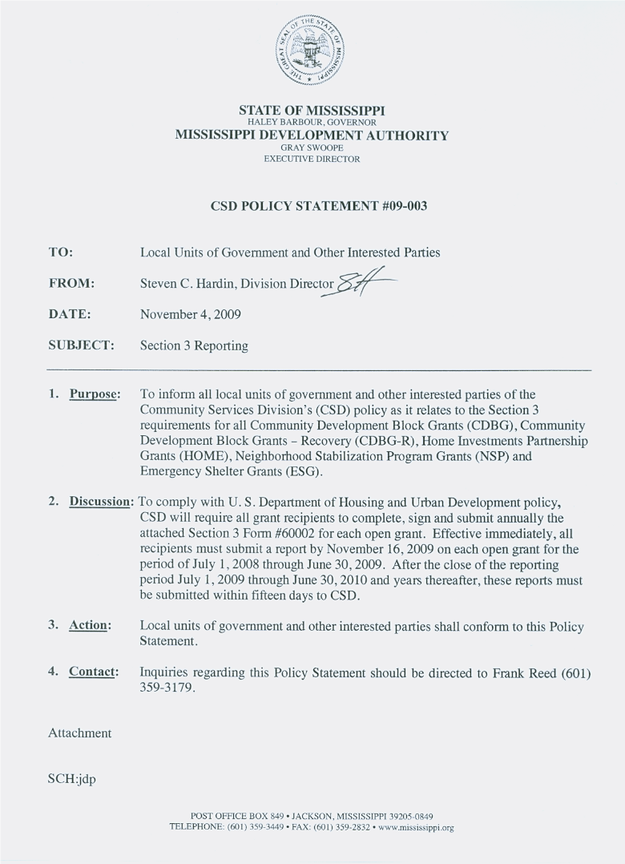
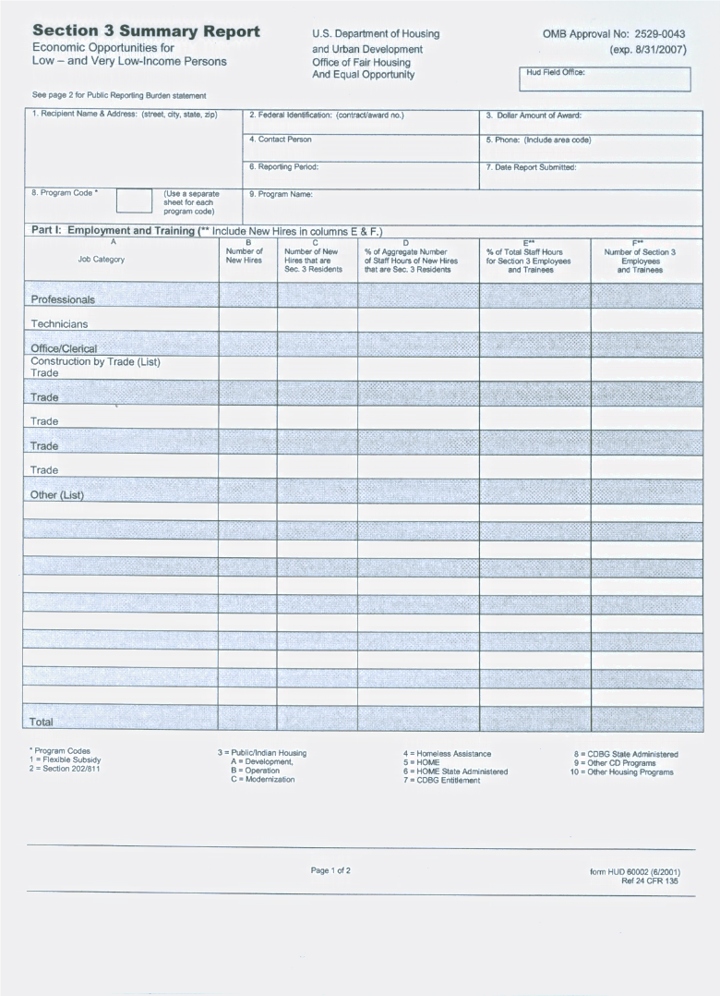
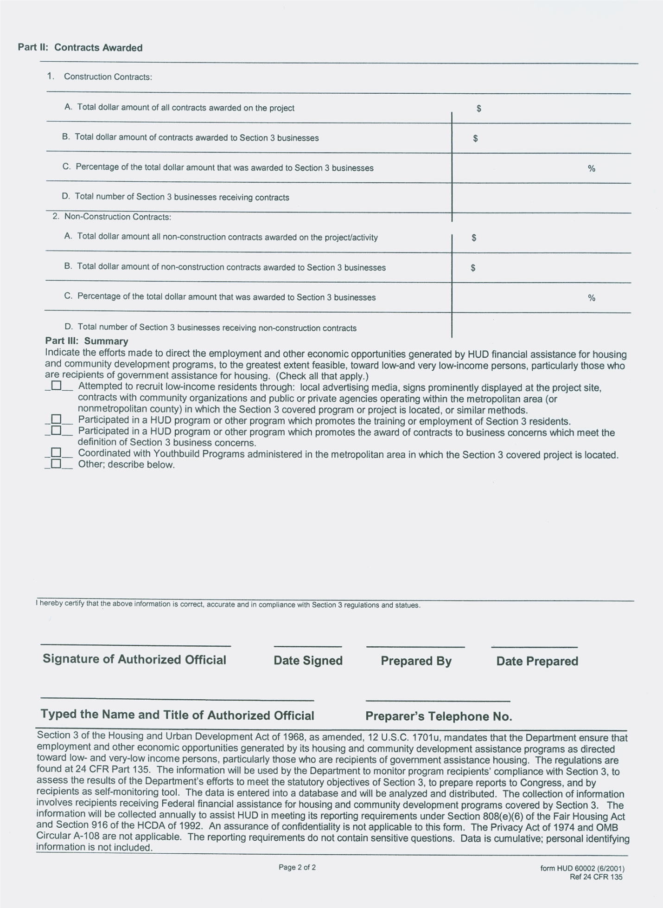

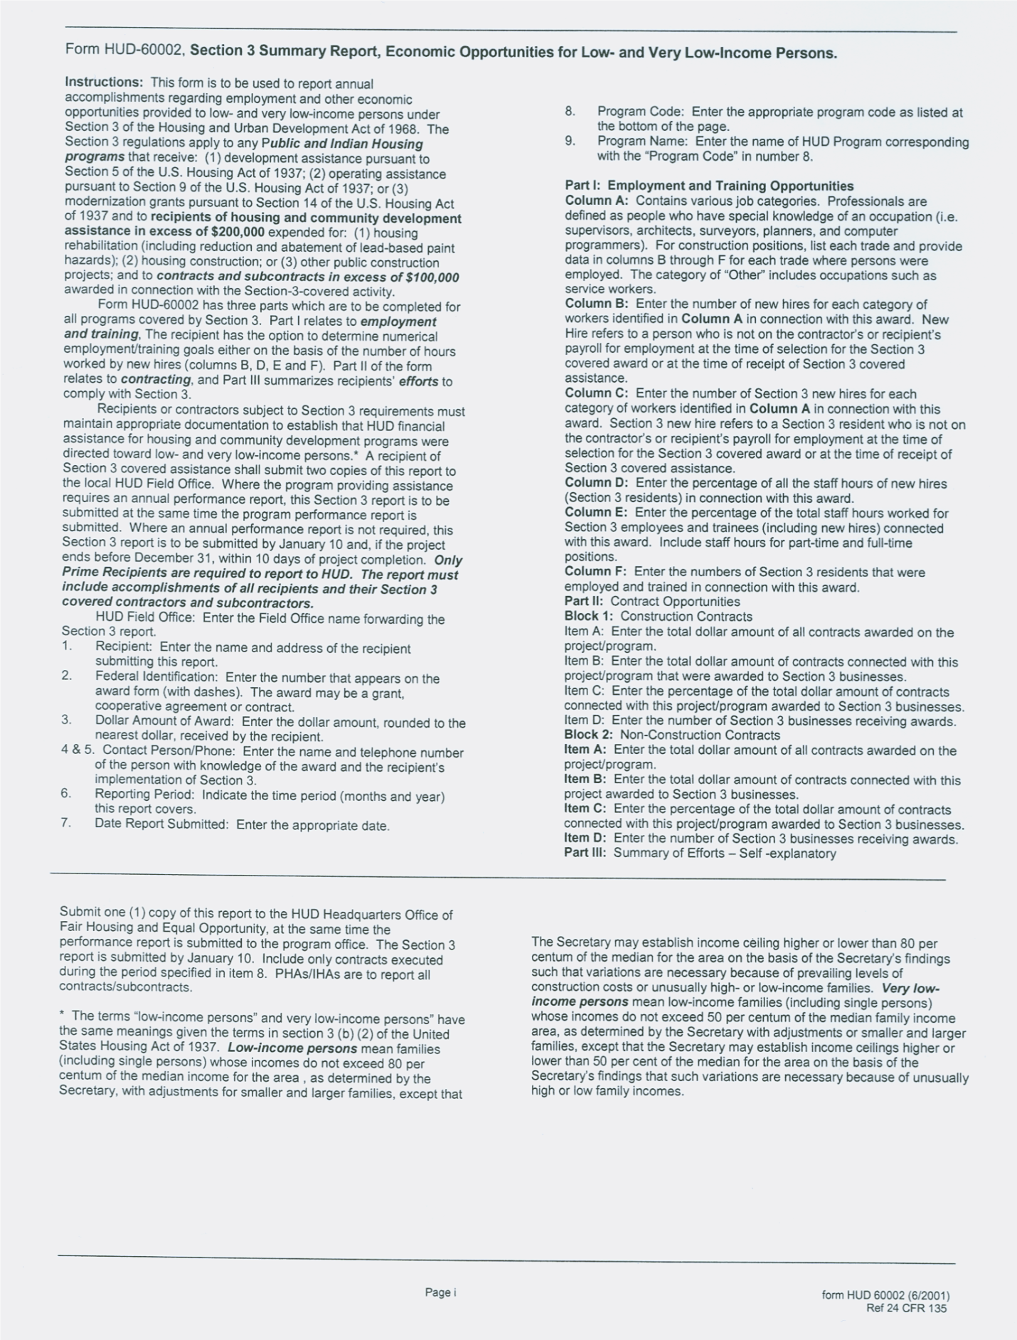
E. AUDITS

The Federal Office of Management and Budget (OMB) Circular No. 2 CFR 200 requires that a state, local government or non-profit organization expending $750,000 or more a year in total cumulative Federal funds must have a Single Audit made in accordance with the Single Audit Act. This audit report must be submitted and received by the Federal clearinghouse designated by OMB and the Federal awarding agency or pass-through entity, no later than nine months following the end of the grant recipient’s fiscal year in which the Federal funds were expended.

If a Single Audit is required, and any of the funds expended were received through MHC requires that a copy of the Single Audit report must be submitted and received by the ESG staff no later than nine months following the end of the grant recipient’s fiscal year in which the Federal funds were expended.

If a Single Audit is not required, (and any of the funds expended were received through MHC), MHC requires that an acceptable Funding Certification Form (for that year only) be submitted and received by the ESG staff. It must be received no later than nine months following the end of the grant recipient’s fiscal year in which the Federal funds were expended, but no sooner than the end of the same fiscal year.

While a qualified Funding Certification Form will exempt the grant recipient from submitting a Single Audit to the ESG staff for the specified fiscal year, it does not exclude the grant recipient from any other requirements of audits or financial statements as requested by MHC or any other Agency or Authority.

Within six months after receipt of grant recipient’s Single Audit report or Funding Certification Form, the ESG staff will send a written management decision regarding the review of the submitted reports.

Audits should be mailed to:

Mississippi Home Corporation
735 Riverside Drive
Jackson, MS 39202
AUDIT REQUIREMENTS OF

MISSISSIPPI HOME CORPORATION

FUNDING CERTIFICATION FORM

Organization: Fiscal Year End: / / Month Day Year
We have exceeded the federal expenditure threshold of $750,000. We will have our Single Audit or Program Specific Audit completed and will submit by _______________, which is no later than nine (9) months after the end of the audited fiscal year.

We have exceeded the federal expenditure threshold of $750,000 but did not receive any of these funds from Mississippi Home Corporation.

We did not exceed the $750,000 federal expenditure threshold required for a Single Audit or a Program Specific Audit to be performed this fiscal year. (Fill out schedule below)
Must be filled out if Single Audit or Program Audit is not required:
Federal Funds
Federal Grantor |  | Pass-through Grantor |  | Program Name &  CFDA Number |  | Contract Number |  | Expenditures
Total Federal Expenditures for this Fiscal Year |  |  |  |  |  |  |  | $

Authorized Signature (Executive Director, Mayor, Board President) |  | Printed Name |  | Title
Mailing Address: |  | City, State |  | Zip Code
Email Address: |  | Phone Number |  | Fax Number
Chief Financial Officer / Comptroller |  | Phone Number |  | Fax Number

Failure to submit this completed form or a completed Single Audit package as described in the audit requirements by the required due date will affect eligibility for future funding.

Submit this form to:
Mississippi Home Corporation
735 Riverside Drive
Jackson, Mississippi 39202
IV. ESG PROGRAM

A. PROGRAM COMPONENTS and ELIGIBLE ACTIVITIES

The ESG program allows funds to be used for five program components:

- Street Outreach;
- Emergency Shelter;
- Homelessness prevention;
- Rapid Re-housing; and
- Homeless Management Information System (HMIS)
- Case Management

A-1. Street Outreach Component (24 CFR 576.101)

If provided for in the contract, ESG funds may be used for costs of providing essential services necessary to reach out to unsheltered homeless people; connect them with emergency shelter, housing, or critical services; and provide urgent, non-facility-based care to unsheltered homeless people who are unwilling or unable to access emergency shelter, housing, or an appropriate health facility. Case management is essential to assessing housing and service needs, arranging, coordinating and monitoring the delivery of individualized services to meet the needs of program participants. This includes case notes. These essential services and staff cost are maximized at fifty percent (50%) of the total amount of the grant allocation. Request for reimbursement for ALL staff MUST be accompanied by an activity sheet, detailing the work they have done in the component pertaining to ESG. *Please refer to A-8 for example activity sheet.

A-2. Emergency Shelter Component (24 CFR 576.102)

ESG funds may be used for costs of providing essential services to homeless families and individuals in emergency shelters and the standard operations of emergency shelters. All items purchased must be for the operation of the shelter. Case management is essential to assessing, arranging, coordinating and monitoring the delivery of individualized services to meet the needs of program participants. These essential services and staff cost are maximized at fifty percent (50%) of the total amount of the grant allocation. Request for reimbursement for ALL staff MUST be accompanied by an activity sheet, detailing the work they have done in the component pertaining to ESG. *Please refer to A-8 for example activity sheet.

A-3. Homelessness Prevention Component (24 CFR 576.103)

ESG funds may be used to provide housing relocation and stabilization services
and short-term rental assistance necessary to prevent an individual or family from moving into an emergency shelter or other place as described in
the homeless definition. Medium-term rental assistance may be provided for up to 24 months. Homelessness prevention assistance may be provided under the “at risk of homelessness” criteria. The costs of homelessness prevention are eligible because the assistance is necessary to help the program participant regain stability in their current housing or move into other housing and achieve stability in that housing. Homelessness prevention must be provided in accordance with the housing relocation and stabilization requirements. Effective case management is essential in securing these services. These essential services and staff cost are maximized at fifty percent (50%) of the total amount of the grant allocation. Request for reimbursement for ALL staff MUST be accompanied by an activity sheet, detailing the work they have done in the component pertaining to ESG. *Please refer to A-8 for example activity sheet.

These requirements are for short-term rental assistance for up to 3 months. Medium-term rental assistance may be provided for up to 24 months. Up to 6 months of rental arrears can be paid under this component. If it is determined that this is all the program participant needs, then assistance should be terminated at that time.

Eligibility for this service requires that a signed lease between the program participant and the landlord or property owner is in place. Verbal rental agreements are not eligible. A typed eviction notice and the affidavit of arrears signed by the landlord (property manager or property owner) are also mandatory documents.

The eviction notice can be a letter/notice from the landlord, property owner or an official legal court document. The document must minimally:

- Identify the ESG applicant and unit where the applicant is the leaseholder,
- Indicate that the applicant must leave their housing within a certain number of days,
- Be signed and dated by the owner/landlord or court
- List the total amount the must be paid to remain in unit.

The ESG applicant and the program participant must be the same. A person who is listed as “in the household” cannot make application for ESG assistance, unless that person is a party to the lease agreement and utility bills.

A-4. Rapid Re-Housing Component (24 CFR 576.104)

ESG funds may be used to provide housing relocation and stabilization services and short-term rental assistance necessary to help a homeless individual or family move as quickly as possible into housing and achieve stability in that housing. This assistance may be provided to program participants who meet the criteria under the homeless definition or are living in an emergency shelter or other place as described in the homeless definition. Rapid re-housing must be provided in accordance with the housing relocation and stabilization requirements. These requirements are for short-term rental assistance for up to 3 months. Medium-term rental assistance may be provided for up to 24 months.

A-5. Housing relocation and stabilization services (24 CFR 576.105)

ESG funds can be used to pay housing owners, utility companies, and other third parties for the following costs:

- Rental application fees that are charged by the owner to all applicants.

- Security deposits that is equal to no more than 2 months’ rent.

- Last months’ rent if it is necessary to obtain housing for a program participant. The last months’ rent may be paid to the housing owner at the time the owner is paid the security deposit and the first months’ rent. This assistance must be included in determining total rental assistance, not to exceed 6 months if previously approved by MHC.

- Prior rental arrears may be paid to a previous landlord if the arrears negatively impact the program participants’ ability to get new housing. To pay this service, the old lease must be provided and the
Affidavit of arrears must be completed and signed by the prior landlord.

- Utility deposits as required by the utility company for all customers. The only eligible utility services are gas, electric, water and sewage.

- Utility payments may be paid for up to 24 months per program participant, per service, including up to 6 months of utility payments in arrears, per service.

- Moving costs may be paid for truck rental or hiring a moving company. Temporary storage fees for up to 3 months are allowable provided the fees are accrued after the program participant begins receiving assistance and before he/she moves into permanent housing. Payment of temporary storage fees that are in arrears is not an eligible expense.
- Hotel or motel vouchers may be paid for a homeless family or individual when no appropriate shelter is available. Hotel or motel stays should be limited to no more than one week. If participants require longer than a 7 day stay, sub-recipients must get approval from MHC staff.

- Rental assistance or arrears to pay for a lot on which a manufactured home is located will require prior MHC approval.

Under no circumstances should any funds be paid directly to the program participant.

A-6. Short-term and medium-term rental assistance (24 CFR 576.106)

The requirement for short- and medium-term rental assistance is that a program participant and a housing owner have a written lease for the provision of rental assistance.

- Short-term rental assistance may be provided for up to 3 months. Case manager must reassess the program participants’ circumstances at least monthly and update case notes into HMIS. Case manager must provide reasonable timelines for program participant to submit information necessary to determine program eligibility.

- Medium-term rental assistance may be provided for up to 24 months. Case manager must reassess the program participants’ circumstances at least monthly and must update case notes into HMIS.

- Payment of rental arrears consists of a one-time payment for up to 6 months of rent in arrears (delinquent), including any late fees on arrears. Any subsequent payment of late fees will have to be with non-ESG funds.

- It may be left to the discretion of the sub-recipient of ESG funds to determine the maximum amount of rent to be paid and the duration to be paid, as well as whether the program participant will share in the cost of payments. This will be determined based on the standards created by the sub-recipients and issued through the contract modifications.

- Program participants who are receiving tenant or project-based rental assistance (section 8), are eligible for security deposits ONLY. The ESG program will not pay rental arrears on the tenant’s portion
of the rental payment.

- Rental assistance cannot be provided for a unit that exceeds the Fair Market Rent established by HUD. This goes for units that the utilities are included. Rent must follow HUD standard of rent reasonableness (comparable like units).

- Rental assistance payments may only be paid to the property owner with whom the sub-recipient has entered into a rental assistance agreement. The rental assistance agreement must be very specific and set forth the terms under which the assistance will be provided (i.e., when the assistance begins and ends). The agreement must also provide that during the term of the agreement, the owner must give the program participant a copy of any notice to vacate the housing unit. This shall also include any complaint used under state or local law to commence an eviction action against the program participant. Only ESG agreements provided by MHC are acceptable documents. All others may result in ineligible costs.

- Payment of late fees will have to be with non-ESG funds.

- Each program participant must have a legally binding typewritten
lease agreement for the rental unit. The lease must be between
the property owner or landlord and the program participant (tenant). The lease must be signed by the landlord and the tenant(s). The lease must clearly provide a full and complete address for the rental property. If the lease agreement is between parent and child, siblings or other relatives, it is invalid, and not reimbursable. If an employee, spouse or other family members of the sub-recipient program has rental property, that employee is not eligible for rental reimbursement through the ESG program.

If the property owner is renting a single-family unit, the lease must also be typewritten and notarized. Handwritten lease agreements or notices from the property/landlord are no longer acceptable.

A-7. Homeless Management Information System (HMIS) (24 CFR 576.107)

If provided for in the ESG contract, the sub-recipient must ensure that data on all persons served and all activities assisted under the ESG program are entered into the applicable community-wide HMIS in the area in which those persons and activities are located, or a comparable database, in accordance with HUD standards on participation, data collection and reporting under a local HMIS. If the sub-recipient is a victim services provider or a legal services provider, it may use a comparable database that collects client-level data over time and generates unduplicated aggregate reports based on the data. Information entered into a comparable database must not be entered directly into or provided to an HMIS.
A-8. Case Management and Activity Sheet (24 CFR 576.101-107)

Case management is essential to assessing housing and service needs, arranging, coordinating and monitoring the delivery of individualized services to meet the needs of program participants. Case notes, including a plan of action, must be accompanied each participant to ensure the efficiency of the program. Activity sheets, detailing the work and amount of time dedicated to ESG is MANADATORY for ALL staff members carrying out these duties that the organization is requesting reimbursement for. These essential services and staff cost are maximized at fifty percent (50%) of the total amount of the grant allocation.

EXAMPLE: MONTHLY TIME ACTIVITY REPORT FOR PROJECT STAFF
Agency:
Month: May |  |  |  | Name
DATE | TIME  IN | TIME OUT | TOTAL  HOURS | PRINCIPAL ACTIVITIES
5/1/18 | 7:00am | 3:30pm | 8 | Assist with Crisis Calls, case management, grant reimbursements, payables
5/2/18 | 7:00am | 3:30pm | 8 | Assist with Crisis Calls, case management, grant reimbursements, review resumes
5/3/18 | 7:00am | 3:30pm | 8 | Assist with Crisis Calls, case management, grant reimbursements, match documentation
5/4/18 | 7:00am | 3:30pm | 8 | Assist with Crisis Calls, case management, grant reimbursements
5/7/18 | 7:00am | 3:30pm | 8 | Payroll Assist with Crisis Calls, case management, Grant reimbursement
5/8/18 | 7:00am | 3:30pm | 8 | Assist with Crisis Calls, case management, review resumes
5/9/18 | 7:00am | 3:30pm | 8 | Answer calls during Treatment Team Meeting, case management, work with Accountant
5/10/18 | 7:00am | 3:30pm | 8 | Assist with Crisis Calls, case management, payables
5/11/18 | 7:00am | 3:30pm | 8 | Assist with Crisis Calls, case management, donation documentation
5/14/18 | 7:00am | 3:30pm | 8 | case management, financials, DAIP & 2nd Chance Reconciliation
5/15/18 | 7:00am | 3:30pm | 8 | Assist with Crisis Calls, Board Meeting Prep
5/16/18 | 7:00am | 3:30pm | 8 | Assist with Crisis Calls, case management, match documents
5/17/18 | 7:00am | 3:30pm | 8 | Assist with Crisis Calls, case management, donations
5/18/18 | 7:00am | 3:30pm | 8 | Assist with Crisis Calls, case management, payables
5/21/18 | 7:00am | 3:30pm | 8 | Payroll Assist with Crisis Calls, case management, interviews
5/22/18 | 7:00am | 3:30pm | 8 | Assist with Crisis Calls, case management, grant reimbursements
5/23/18 | 7:00am | 3:30pm | 8 | Answer calls during Treatment Team Meeting, case management, grant reimbursements
5/24/18 | 7:00am | 3:30pm | 8 | Assist with Crisis Calls, case management, financial reconciliation
5/25/18 | 7:00am | 3:30pm | 8 | Assist with Crisis Calls, case management, budgets
5/28/18 | 7:00am | 3:30pm | 8 | Holiday
5/29/18 | 7:00am | 3:30pm | 8 | Assist with Crisis Calls, case management, purchasing
5/30/18 | 7:00am | 3:30pm | 8 | Assist with Crisis Calls, case management, review resumes
5/31/18 | 7:00am | 3:30pm | 8 | Assist with Crisis Calls, case management, grant reimbursements, payables

EMPLOYEE SIGNATURE: ________________________________ DATE: _____________

EXECUTIVE DIRECTOR SIGNATURE: ____________________ DATE: _____________

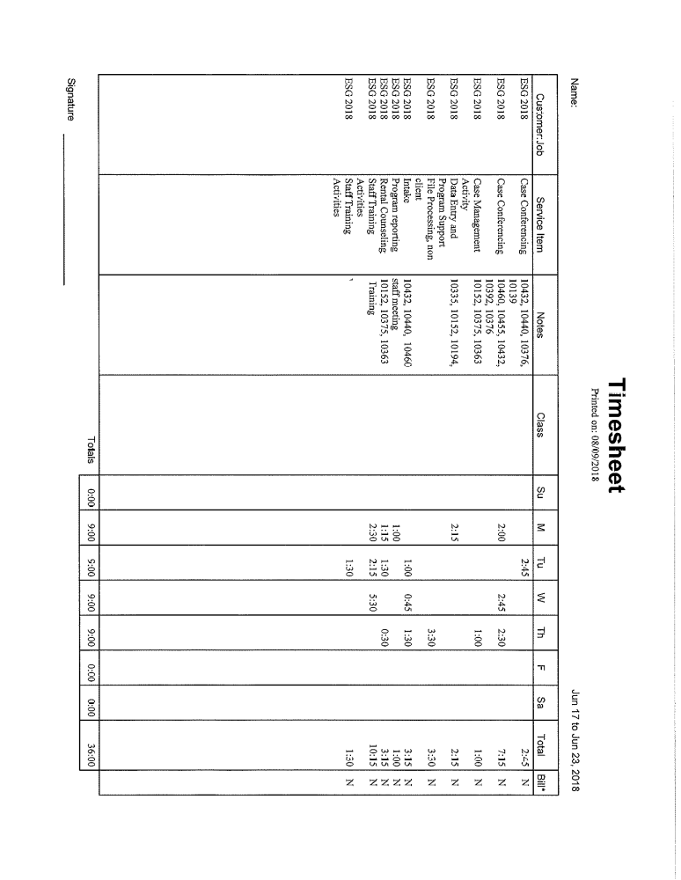

B. PROGRAM REQUIREMENTS

B-1. But For

One of the most significant factors in determining a household’s level of need
for receiving HPRP was the concept of “but for”. The ESG program embraces that same concept in determining eligibility. To establish eligibility for ESG, an initial consultation with a case manager is to be conducted and an assessment made as to whether the household will require emergency shelter or be literally homeless “but for” this ESG financial assistance. The case manager should be able to make the determination that the household has no other available housing options or lacks financial resources that would prevent them from becoming homeless. This includes no family support and no other social support networks.

The initial consultation conducted by the case manager should make the necessary determination of the range of services that may be required for the program participant. The structure of the ESG program is designed to provide and promote comprehensive services to the program participant. This is an effort to assist the program participant with gaining and maintaining stability in all facets of life, not just housing. The case manager must be knowledgeable of all services that are available in a community to effectively service the program participant.

Additionally, each program participant receiving homelessness prevention or rapid rehousing assistance must be required to meet regularly with a case manager (except where prohibited by the Violence Against Women Act (VAWA) and the Family Violence Prevention and Services Act (FVPSA)), and the assistance provider must develop an individualized plan to help that program participant retain housing after the ESG assistance ends.

B-2. Conflicts of Interest

It appears that the “but for” concept was developed to reduce the incidence of appearances of conflicts of interest. HUD guidance states “no person who exercises or has exercised any functions or responsibilities with respect to activities under the ESG program, or who is in a position to participate in a decision-making process or gain inside information with regard to activities assisted under the program, may obtain a financial interest or benefit from an assisted activity; have any financial interest in any contract, subcontract, or agreement with respect to an assisted activity; or have a financial interest in the proceeds derived from an assisted activity, either for him or herself or for those with whom he or she has family or business ties, during his or her tenure or during the one-year period following his or her tenure”. The state issued guidance which expanded the definition of relative to include a “spouse, child, parent or any person related by blood or marriage within the third degree”. This definition is based on the Ethics in Government Act and the state nepotism statute. It is the responsibility of the Grant Administrator to properly disclose the conflict of interest provision to interested participants. If it is found that a conflict of interest has occurred, the grant recipient may be required to repay program funds, using non-federal funds. Failure to repay the funds may result in termination of participation in any future HUD funded programs. There will be no exceptions to this guidance granted by MHC.

C. MANDATORY DOCUMENTATION

Determination of eligibility of a program participant for ESG financial services must be conducted by the sub-recipient through an initial consultation with a case manager. The case manager should be able to determine the amount and types of assistance the individual or family needs to regain permanent housing stability. These evaluations must be conducted in accordance with a centralized or coordinated assessment system.

The sub-recipient must re-evaluate the program participant’s eligibility and the types of assistance needed at least every 3 months. At a minimum, each re-evaluation must establish that: (a) the program participant does not have an annual income that exceeds thirty percent (30%) of the median family income for the area for homeless prevention, as determined by HUD; and (b) the program participant lacks enough resources and support networks necessary to retain housing without ESG assistance.

The sub-recipient may also require each program participant receiving homelessness prevention or rapid re-housing assistance to provide notification
of changes in income or other circumstances (household composition) that affect the program participant’s need for assistance under ESG.

The program participant is required to provide the circumstances that resulted in he/she is becoming homeless or at risk for homelessness. A program participant must be able to provide valid documentation for requesting the financial assistance in the form of:

- Application. This document is to be completed by the case manager and signed by the program participant. The case manager must provide complete detail of how the program participant became homeless or has been put “at risk” of becoming homeless. All information provided in the application should be certified as true and correct to the best of the parties’ knowledge. Any application that is not signed by both the case manager and the program participant is
not a valid document. The ESG application is mandatory for all program participants.

- Income verification. HUD defines income as “any money that goes to, or on behalf of, the head of household or spouse (even if temporarily absent) or to any other household member”. Annual income includes the current gross income of all adult household members and unearned income attributable to a minor. The types
of income to be counted include:

- Earned Income
- Self-Employment/Business Income
- Interest & Dividend Income
- Pension/Retirement Income
- Unemployment & Disability Income
- TANF/Public Assistance
- Alimony, Child Support and Foster Care Income
- Armed Forces Income

Annual income must be calculated using HUDs income calculation worksheet. The case manager must obtain verification of all income reported
by the program participant. If program participant has indicated previous employment but is not currently employed the case manager must provide documentation from previous employer or from unemployment compensation. This documentation is mandatory for all program participants and adult household members.

- Asset verification. Assets are defined as cash or material items that can be converted to cash quickly. They include real and/or personal property and investments that a household may possess, including assets that are owned by more than one person, but allow unrestricted access to the applicant. Assets include:

- Amounts in checking and saving bank accounts.
- Stocks, bonds, savings certificates, money market funds, and other investment accounts.
- The cash value of trusts that may be withdrawn by the household.
- IRA, Keogh and similar retirement savings accounts, even when early withdrawal will result in a penalty.
- Lump sum receipts of cash received and accessible by household, such as inheritances, capital gains, lottery winnings, insurance settlements, and other claims.

Household assets generally are not counted as income, except for interest and dividend income. However, household assets should be taken into consideration when determining whether a household has other financial resources to obtain or maintain housing.

- Lease Agreement. This document must clearly list all the parties to the lease; must provide terms and conditions; must have a beginning and ending date and must be signed by all involved parties (landlord and tenant). If the lease has expired, it must have a clause addressing the continuance of the agreement on a month- to- month arrangement unless State law dictates that the lease automatically continues under a month-to-month or annual arrangement until the lease is renewed or is otherwise terminated. In the event the least is extended on a month- to- month agreement, the landlord must still provide a written statement which clearly indicates this is month- to- month. The written lease agreement is mandatory for all program participants applying for ESG assistance.

- Eviction Notice, if applicable. This document must be typewritten and indicate the amount of rent due, the amount of time tenant has failed to pay rent and the length of time he/she must pay the delinquent rent or vacate the property within a certain number of days. The eviction notice must be signed and dated by the landlord or provided in a court order. This document is required for those “at risk” of becoming homeless.

- Rental Assistance Agreement. The rental assistance agreement must be very specific and set forth the terms under which the assistance will be provided (i.e., when the assistance begins and ends). This document is mandatory for all program participants.

Additional documentation required for the program participants’ file are listed below:

- Rent Reasonableness checklist. Rent reasonableness should be determined by considering the following: (1) the reasonableness in relation to rents being charged for comparable unassisted units, taking into account the location, size, type, quality, amenities, management, and maintenance of each unit; and (2) the rent should not be in excess of the rent currently being charged by the same owner for properties (if comparable to the unit in which the participant will be leasing) as well as those actual rents charged. Rent reasonableness must be determined for all units for which ESG rental assistance and/or security deposit assistance is being provided. If the rent for the unit does not meet the rent reasonableness, then ESG funds cannot be used to assist the household in that unit. Furthermore, ESG funds cannot be used to pay the rent up to the rent reasonableness standard, while the tenant pays the remainder. This document is mandatory for all program participants

- Habitability Standards. These standards apply when a program participant is receiving financial assistance and moving into a new (different) unit, as well as, homelessness prevention. Inspections must be conducted upon initial occupancy. This document is mandatory for all program participants

- Lead-Based Paint checklist, if applicable. This document is intended to guide grantees through the lead-based paint inspection process to ensure compliance with regulations found at 24 CFR 35, Parts A, B, M and R to prevent lead-poisoning in young children. ESG staff can use this checklist to document any exemptions that may apply, whether any potential hazards have been identified, and if safe work practices and clearance are required and used. This document should be kept in each program participants’ file.

- Affidavit of Arrears, if applicable. This document must be signed and dated by the landlord and provide the specific amounts and the number of months that the tenant has failed to pay rent. This document is required for those “at risk” of becoming homeless.

- Rental Payment Ledger, if applicable. This document must come from the apartment management and must be in alignment with the affidavit of arrears. If tenant is renting from a homeowner, this information may not be available, so the affidavit of arrears will be enough. This document is required for those “at risk” of becoming homeless.

- Termination of Assistance, if applicable. If a program participant violates program requirements, the sub-recipient may terminate the assistance in accordance with a formal process established by the sub-recipient that recognizes the rights of individuals affected. To terminate rental assistance or housing relocation and stabilization services to a program participant, the required formal process, at a minimum, must consist of:

- Written notice to the program participant containing a clear statement of the reasons for termination;
- A review of the decision, in which the program participant is given the opportunity to present written or oral objections before a person other than the person who made or approved the termination decision; and
- Prompt written notice of the final decision to the program participant.

Records

All records for the ESG program must be retained for the greater of five (5) years or for the period specified below. Copies made by microfilming, photocopying, or similar methods may be substituted for the original records.

- Documentation of each program participants’ qualification as a family or individual at risk of homelessness or as a homeless family or individual and other program participant must be retained for five (5) years after the expenditure of all funds from the grant under which the program participant was served.

Access to records

The HUD Office of the Inspector General, and the Comptroller General of the United States, or any of their authorized representatives, must have the right of access to all books, documents, papers, or other records of the recipient and its sub-recipients that are pertinent to the ESG grant, to make audits, examinations, excerpts, and transcripts. These rights of access are not limited to the required retention period but last if the records are retained.

Remedial Actions and Sanctions

Remedial actions and sanctions for failure to meet the ESG program requirement will be designed to prevent a continuation of the deficiency; mitigate, to the extent possible, its adverse effects or consequences; and prevent its recurrence through the following actions:

- The State may instruct the recipient to submit and comply with proposals for action to correct, mitigate, and prevent noncompliance with ESG requirements including:

- Preparing and following a schedule of actions for carrying out activities affected by the noncompliance, including schedules, timetables, and milestones necessary to implement the affected activities;

- Establishing and following a management plan that assigns responsibilities for carrying out the remedial actions;

- Canceling or revising activities likely to be affected by the noncompliance, before expending ESG funds for the activities;

- Reprogramming ESG funds that have not yet been expended from affected activities to other eligible activities;

- Suspending disbursement of ESG funds for some or all activities;

- Reducing or terminating the remaining grant of sub-recipient and reallocating those funds to other sub-recipients; and

- Making matching contributions before or as draws are made from the recipients’ ESG grant.

- The State may suspend payments to the extent HUD deems it necessary to preclude the further expenditure of funds for affected activities.

- The State may remove the recipient from participation in reallocations of funds.

- The State may deny matching credit for all or part of the cost of the affected activities and require the recipient to make further matching contributions to make up for the contribution determined ineligible.

- The State may require the recipient to reimburse its line of credit in an amount equal to the funds used for the affected areas.

- The State may reduce or terminate the remaining grant of a recipient and reallocate those funds to other recipients;

- The State may condition a future grant.

- The State may take other remedies that are legally available.

Allowable Program Activities



